NCG 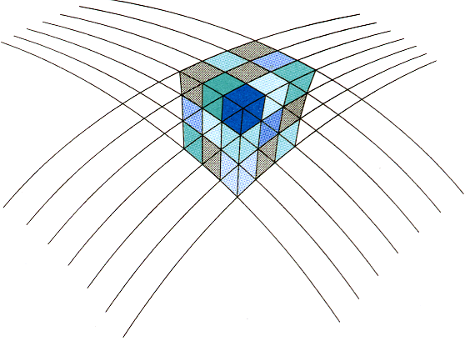
Netherlands Center for Geodesy and Geo-informatics

Call for Abstracts

NCG Symposium 2016

Enschede, 30 November 2016

The Netherlands Center for Geodesy and Geo-informatics (NCG) would like to establish an annual platform for exchange and discussion of scientific research in the Netherlands in the field of Geodesy and Geo-informatics.

The NCG calls for abstracts of scientific research results to be presented at the NCG Symposium 2016. Abstracts are welcomed on all topics in the field of geodesy and geo-informatics. To stimulate discussion staff members of universities participating in the NCG have been asked to coordinate sessions on topics like 3D geo-information, monitoring, point clouds, indoor geo-information, governance, and crowd sourcing. Further sessions are available to accommodate presentations on other topics.

Based on abstract reviewing the programme committee will select the abstracts for oral and poster presentations. The deadline for abstract submission is 4 October. Authors shall be notified by
21 October. Please use the form on the next page to prepare your abstract.

The symposium will be held at the Faculty ITC, University of Twente, Hengelosestraat 99, 7514 AE Enschede. We’re looking forward to your presentations.

Ramon Hanssen
George Vosselman
Jaap Zevenbergen
(programme chairs)

NCG
Netherlands Center for Geodesy and Geo-informatics

Abstract submission for the NCG Symposium 2016

Abstract submission deadline: 4 October 2016
Please submit your abstract to Sieb Dijkstra, info@ncgeo.nl

Name:

Affiliation:

E-mail:

Presentation title:

Abstract (300-500 words and optionally 1-2 figures):

